**Project Design Phase-II**

**Data Flow Diagram &User Stories**

|  |  |
| --- | --- |
| Date | 31October2022 |
| Team ID | PNT2022TMID50333 |
| Project Name | Project - IOT based safety gadget for children safety and monitoring |
| Maximum Marks | 4 Marks |

**Data Flow Diagrams:**

A Data Flow Diagram (DFD) is a traditional visual representation of the information flows within a system. A neat and clear DFD can depict the right amount of the system requirement graphically. It shows how data enters and leaves the system, what changes the information, 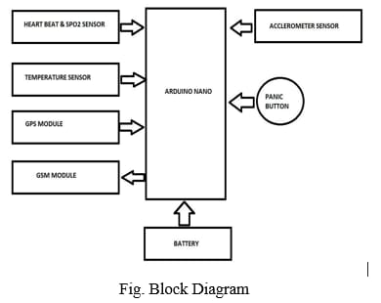

Example: FLOW CHART DIAGRAM /EQUIPMENTS

. 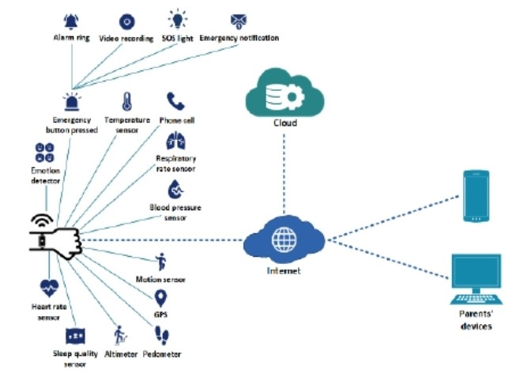

**Example: (Simplified diagram )**

**User Stories:**

Use the below template to list all the user stories for the product.

| **User Type** | **Functional Requirement (Epic)** | **User Story Number** | **User Story / Task** | **Acceptance criteria** | **Priority** | **Release** |
| --- | --- | --- | --- | --- | --- | --- |
| Customer (Mobile user/smart watch user) | Registration | USN-1 | As a user, I can register for the application by entering my email, password, and confirming my password. | I can access my account / dashboard | High | Sprint-1 |
|  |  | USN-2 | As a user, I will receive confirmation email once I have registered for the application | I can receive confirmation email & click confirm | High | Sprint-1 |
|  |  | USN-3 | As a user, I can register for the application through Facebook | I can register & access the dashboard with Facebook Login | Low | Sprint-2 |
|  |  | USN-4 | As a user, I can register for the application through Gmail |  | Medium | Sprint-1 |
|  | Login | USN-5 | As a user, I can log into the application by entering email & password |  | High | Sprint-1 |
|  | Dashboard |  |  |  |  |  |
| Customer (Web user) |  |  |  |  |  |  |
| Customer Care Executive |  |  |  |  |  |  |
| Administrator |  |  |  |  |  |  |
|  |  |  |  |  |  |  |
|  |  |  |  |  |  |  |
|  |  |  |  |  |  |  |

Example: DFD Level 0 (Industry Standard)